# Module 7 – Planning



## Module 7 objectives

At the end of this module, you will be able to…

* talk about why we plan and the value of planning for a business • use the present simple to express facts.
* use business terminology.
* investigate and present facts as a result of your research.
* talk about the elements of a plan.
* identify the use of *will* to express commitment.
* use word families.
* outline a business plan.
* talk about the competencies necessary to found a startup.
* talk about controlling a business plan.
* use present perfect to talk about progress.
* write an email to report progress.
* talk about different tools for business control.
* talk about the importance of having a plan B.
* use the past tense to tell a story.
* use conditional sentences to talk about an imaginary past.
* talk about contingency planning.

**Lesson 1 – Why plan?**

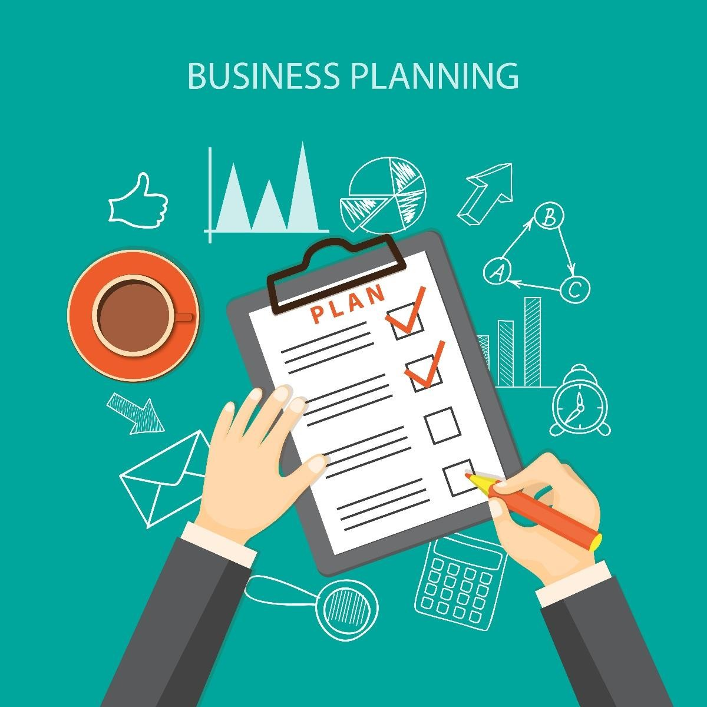

## Lesson 1 objectives

At the end of this lesson, you will be able to…

* talk about why we plan and the value of planning for a business • use the present simple to express facts.
* use business terminology.
* investigate and present facts as a result of your research.

## Activate

Discuss with a partner. Share your answers with the rest of the class.

* Do you like to plan?
* Why is planning important for a business?

## Learn



1. Listen to the podcast. Compare your answers to the Activate section with the information in the podcast.

1. Listen to the audio again. Work with a partner. Read the following statements. Are they **true** or **false**? Correct the sentences that are false.

* 1. People like planning.
  2. Lack of planning is one of the main reasons small businesses fail.
  3. The financial plan helps a company control its income.
  4. The marketing plan helps the company generate sales.
  5. Planning on who will be in key positions within the company in the future is not important.

Check your answers by reading audio script 7.1.

1. Work with a partner. Read audio script 7.1 and underline as many examples of the present simple as you can find. Look at the examples underlined in red.

1. Work with a partner. Why is the present simple used so much in the podcast?

## Do

1. Work individually. In your portfolio, write sentences about why you like or do not like planning. Stand up and compare what you wrote with your classmates. Try to find someone who is an identical match to you in terms of your opinions.

**Let’s use it!**

1. Work in groups of three. Investigate online to find arguments for why we should plan. Write what you discover in your portfolio.

1. Prepare a PowerPoint presentation with what you found out in your investigation in Activity 6. Record voice narration for it. Be sure to use the present simple to talk about your facts. Upload your presentation onto the class Wiki. Vote for the best presentation. Justify your vote.

**How did I do? Evaluate yourself.**

|  |  |  |  |  |
| --- | --- | --- | --- | --- |
|  | **I can’t yet…** ☹ | **More or less (-)** | **Yes, I can!** 😊 | **If you need help, go to…** |
| I can talk about the importance of planning. |  |  |  | Activate and Activity 1 |
| I can use the present simple to express facts. |  |  |  | Activity 5 |
| I can investigate and present facts as a result of my research. |  |  |  | Activities 6 & 7 |
| I can use business terminology. |  |  |  | I can communicate! |

|  |
| --- |
| **I can communicate!**  **Business terminology**  Work with a partner. Read audio script 7.1. Underline the business words and phrases. Choose three words/phrases and write sentences to show their meaning.   1. ___________________________________ 2. ___________________________________ 3. ___________________________________ |

# Lesson 2 – The elements of a plan

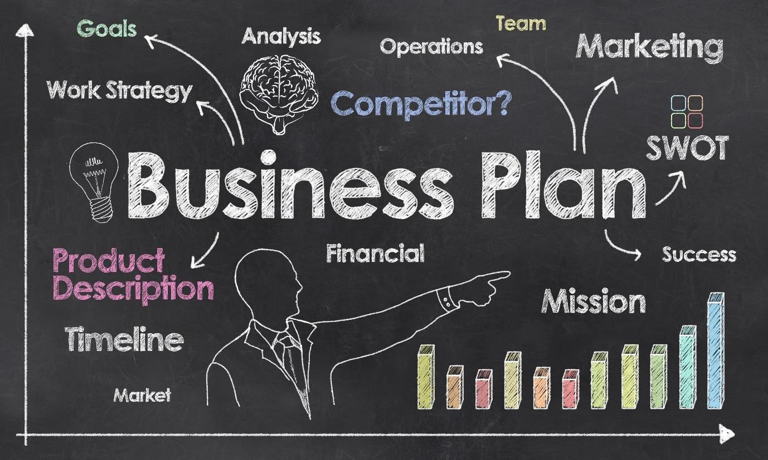

## Lesson 2 objectives

At the end of this lesson, you will be able to…

• talk about the elements of a plan.

* identify the use of *will* to express commitment.
* use word families.
* outline a business plan.
* talk about the competencies necessary to found a startup.

## Activate

Discuss with a partner. Share your answers with the rest of the class.

* Have you ever written a plan?
* What elements should be included in a business plan?

## Learn

1. Work with a partner. Read the following entry from a business textbook. Compare your answers to the questions in the Activate section with the information.

**The SOSTAC planning structure**

A successful plan has certain essential elements. When we write a plan, we need to take this into account. If we forget one of the parts, we do not have a complete plan and we can run into trouble. The elements of a complete plan can be remembered by the acronym SOSTAC.

We start any kind of plan with the current situation (the S in SOSTAC). You need to analyze where you are before you go any further. In business, there are many tools you can use to analyze the current situation. One of these is a SWOT analysis, where you analyze the strengths, weaknesses, opportunities and threats facing the business. You can also conduct a competitor analysis, looking at each company’s strengths, weaknesses and what they charge. Another kind of analysis that we can include in the current situation section is the PEST analysis. In a PEST analysis, you analyze the political, economic, social and technological situations in the country you live in. This is important because a business is always developed within a context.

The O in SOSTAC stands for objectives. These are what you want to achieve based on the current situation. Objectives should be SMART: specific, measurable, achievable, relevant and time-oriented. They are expressed using the modal verb *will* to show a commitment or the phrase *be going to* to express intentions.

The next element in your plan is your strategy. This is the S of SOSTAC. The strategy is the big picture of how you are going to achieve your goals. An example of a business strategy is having a circus with no animals. Which a few years ago would have been unthinkable but is now the central strategy of many circuses. Removing the animals reduces operating costs, thereby making the circus more profitable. It is also appreciated by the public as it supports animal rights.

After the strategy come your tactics. A tactic is a like a mini-strategy to achieve your goals. An example of a tactic is a seasonal special offer your business uses to attract customers.

The A of SOSTAC stands for actions. These are the specific details of who does what and when. The actions are often presented in a Gantt chart. A Gantt chart shows the actions, when they will happen and who is responsible for them.

The C of SOSTAC is control. In this part of the plan, the process of how the plan will be monitored is explained. Here we define the indicators that we will use to define success. We may also define what we do in the case of not achieving objectives.

1. Work with a partner. Read the textbook entry again and answer the following questions according to the information in the text.

* 1. In the Current situation section of the plan…
     1. we use different tools to analyze the current situation.
     2. we write our objectives.
     3. we write a short description of the current situation of the business.
     4. we describe our company.

* 1. A SMART objective is…
     1. specific, marketable, active, reactive and technological.
     2. specific, marketable, active, realistic and time-bound.
     3. specific, measurable, achievable, realistic and time-oriented.
     4. specific, measurable, achievable, relevant and time-oriented.

1. In the Strategy section of our plan, we put…
   * 1. what we want to achieve.
     2. how we are going to achieve our objectives.
     3. what the main ingredient will be to achieve our objectives.
     4. SMART objectives.

1. In the Tactics sections of our plan, we put...
   * 1. our strategies.
     2. the small ideas that will help us achieve our objectives.
     3. who is doing what and when.
     4. ideas for beating the competition.

1. Actions need…
   * 1. to be achieved.
     2. to have a time by when they will be achieved, a person responsible for them and a description of what they are.
     3. to be explained.
     4. to de defined and assigned to a person.

1. The Control section of the plan…
   * 1. explains how we will measure the success of the plan.
     2. measures the success of the plan.
     3. controls the plan.
     4. gives us a sense of control over the plan.

1. Work with a partner. Look at how the modal auxiliary verb *will* is used in the text. Is it used to…

* 1. express an intention?
  2. express a prediction?
  3. express a commitment?

1. Work with a partner. Complete the table to make word families using vocabulary from the text. Choose three of the words and write sentences to show their meaning in your portfolios.

|  |  |  |
| --- | --- | --- |
| **Noun** | **Verb** | **Adjective** |
| planning/plan |  |  |
| success |  | successful |
| analysis | analyze |  |
| strength |  |  |
| weakness |  |  |
|  |  | responsible |

## Do

1. Complete the following sentences so that they are true for you. Compare your sentences with your partner.

* 1. I __________________________________________________ my plans.
  2. Success for me is ____________________________________________.
  3. A strength of mine is __________________________________________.
  4. A weakness of mine is _________________________________________.

1. Rewrite your sentences in number 5 using the word in brackets.

* 1. ___________________________________________________ (to plan)

* 1. ___________________________________________________ (successful)

* 1. ___________________________________________________ (strong)

* 1. ___________________________________________________ (weak)

**Let’s use it!**

1. Work with a partner. Choose one of the following ideas for a startup and write the outline for a business plan using the SOSTAC structure.
   * An innovative restaurant
   * A new type of medicine
   * A killer app
   * An idea of your own

1. When you have finished creating your outline, present it in PowerPoint and upload your presentation onto the class Wiki. Vote as a class for the best business plan.

**How did I do? Evaluate yourself.**

|  |  |  |  |  |
| --- | --- | --- | --- | --- |
|  | **I can’t yet…** ☹ | **More or less (-)** | **Yes, I can!** 😊 | **If you need help, go to…** |
| I can talk about the elements of a plan. |  |  |  | Activate and  Activities 1 & 2 |
| I can identify the  use of *will* to express commitment. |  |  |  | Activity 3 |
| I can use word families. |  |  |  | Activities 5 & 6 |
| I can outline a business plan. |  |  |  | Activities 7 & 8 |
| I can talk about the competencies necessary to found a startup. |  |  |  | I am competent! |

**I am competent!**

**What is a startup?**

A startup is a new business, which often uses technology in its strategy, offering an innovative product or service. The growth of a startup is normally rapid, achieving a multi-million-dollar turnover within its first few years of operation.

Work with a partner. What kind of person founds a startup? Would you like to do this? Why/why not? Post your ideas onto the class Wiki.

# Lesson 3 – Controlling a plan



## Lesson 3 objectives

At the end of this lesson, you will be able to…

* talk about controlling a business plan.
* use present perfect to talk about progress.
* write an email to report progress.

## Activate

Work with a partner. Discuss the following questions.

* What ways do we use to control a business plan?
* Why is it important to control a business plan?

## Learn

1. Work with a partner. Listen to the meeting between David and his boss. Is the project going according to plan? What is the problem?

1. Work with a partner. Listen to the audio again. Decide if the following statements are true, partly true or false. Use the information in the audio to make the partly true and false statements true.

* 1. The project is ahead of schedule.
  2. The steel girders are arriving from China next week.
  3. The steel girders are used to make the foundations of the building.
  4. They ordered the steel girders from China because it is more economical.
  5. Goods from China arrive fast.
  6. The project is going to be 20% more expensive.
  7. They are going to sue the steel company in China.

Read audio script 7.2 at the end of this module to check your answers.

1. Work with a partner. Read the text again. Look at the verbs underlined in red and decide which rule is correct.

* 1. David uses this verb form to talk about actions in the past.
  2. David uses this verb form to talk about progress on the project.
  3. David uses this verb form to talk about the future.

1. Work with a partner. The verb form David is using is called present perfect. Look at the text to discover how it is formed and complete the rule.

I / you / he / she / it / we / they + ________ or _______ + past participle (Subject)

## Do

1. Work with a partner. Use the language you discovered in Activities 3 and 4 to write the three most useful things you have learned on this course so far. Compare your answers as a class.

On this course, we have learned…

* 1. _______________________________________
  2. _______________________________________
  3. _______________________________________

**Let’s use it!**

1. Work in pairs. Finish the following email to your boss reporting progress on a project. Use the points listed below. Make sure to use the language you learned in the Learn and Do sections. Write 200 words only.

* + - Location for new office identified
    - Three possible options for office spaces chosen
    - Quotations for rent ordered
    - Local company constituted
    - Key staff recruited
    - Next update in a week’s time

Dear Boss,

We hope you are well!

We would like to give you a brief update on the project to open a new office in Hong Kong.

1. When you have written your email, upload it onto the class Wiki. Read your classmates emails. Edit them to correct mistakes and improve content.

**How did I do? Evaluate yourself.**

|  |  |  |  |  |
| --- | --- | --- | --- | --- |
|  | **I can’t yet…** ☹ | **More or less (-)** | **Yes, I can!** 😊 | **If you need help, go to…** |
| I can talk about controlling a business plan. |  |  |  | Activate, Activities 1 |
| I can use the present perfect to report on progress. |  |  |  | Activity 5 |
| I can write an email to report progress. |  |  |  | Activities 6 & 7 |
| I can talk about different tools for control. |  |  |  | I am competent! |

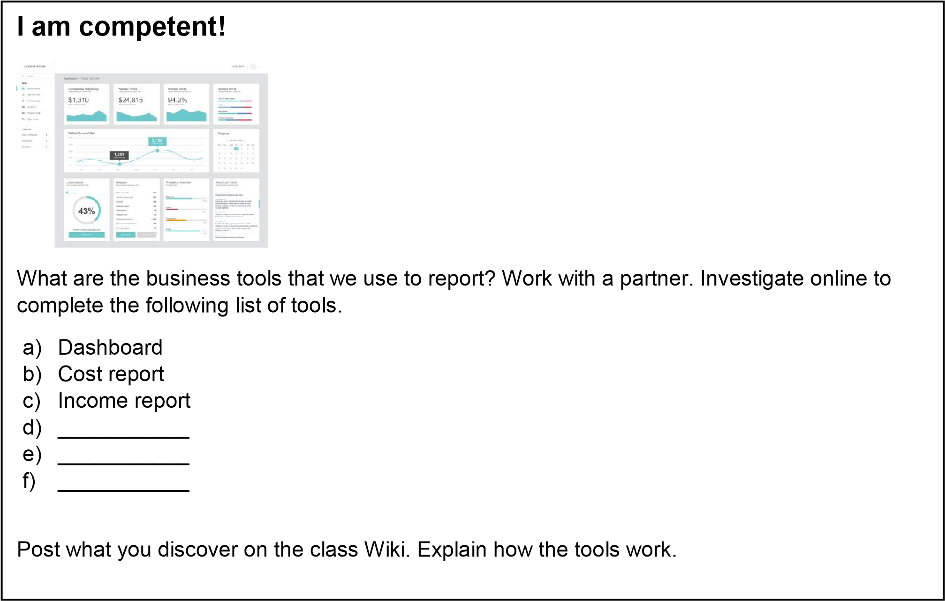

# Lesson 4 – Having a plan B



## Lesson 4 objectives

At the end of this lesson, you will be able to…

* talk about the importance of having a plan B.
* use the past tense to tell a story.
* use conditional sentences to talk about an imaginary past.

## Activate

Discuss the following questions with a partner.

* What is a plan B? Why is it important to have one?
* Do you normally have a plan B?

## Learn

1. Work with a partner. Read the business case study below. What were the consequences for Alan and Gilberto of not having a plan B for their business?



Alan and Gilberto had a great idea. They were going to make a killer app. In some ways, this was going to be like all other apps. It would use GPS – of course! It would also match you with what you’re looking for. But it was going to be killer because it was going to be quintessentially Mexican. The app would detect the best taco stalls in Mexico City by geolocating you and matching you with the taco stand with the best reputation in the area you’re in.

Alan and Gilberto wrote a detailed business plan. They analyzed the market and they discovered that most of the millions of inhabitants living in Mexico City ate at taco stands at some stage in the week. This was an enormous potential market. The income for the business was going to come from the taco stand owners themselves. The idea was that they were going to pay to advertise their stand on the app. They did an income projection and their idea generated lots of excitement. They received lots of investment.

However, very quickly Alan and Gilberto’s plan began to fall apart. Almost none of the taco stand owners were willing to invest in the app. On one hand, they didn’t understand what it was, nor did they see the benefit in it for them. On the other, they did not have the extra money to invest in promotion. It was difficult enough to make ends meet as it was. Within a few months, they had to close their doors and their investors lost all their money.

If only Alan and Gilberto had thought of a plan B, they would have made money!

1. Work with a partner. Read the case study again. Decide which of the following statements are true and which are false. Correct the false ones.

* 1. Alan and Gilberto made a killer app for learning languages.
  2. Their clients were the people who eat tacos.
  3. Their business failed because the taco stand owners were not prepared to pay for their service.
  4. The taco-stand owners did not like the app.
  5. Their investors made money.

1. Work with a partner. What does the following sentence mean? Check your answers as a class.

If only Alan and Gilberto had thought of a plan B, they would have made money!

* 1. Alan and Gilberto made money.
  2. Alan and Gilberto had a plan B.
  3. With a plan B, Alan and Gilberto would have made money.

1. Look at the sentence in red in the text and complete the rule.

If + subject + _______ + past participle, subject + _______ + have + past participle

## Do

1. Work individually. Think about your past. Complete the following sentences so that they are true for you. Compare your answers with your classmates. What is your favorite sentence?

* 1. If I had ________________, then I would ___________________________.
  2. If I hadn’t ________________, then I would _________________________.
  3. If I had ________________, then I wouldn’t _________________________.

**Let’s use it!**

1. Work in pairs. Read the case study again. Decide on what plan B Alan and Gilberto should have made to ensure the success of their business.

1. When you have decided on a plan B for Alana and Gilberto, post your ideas onto the class Wiki. Vote for the best idea. Justify your votes.

|  |
| --- |
| **I am competent!**  **Contingency plans**    A plan B is also sometimes known as a contingency plan. The term is normally used for crisis situations. Work with a partner to complete the list of situations where we need to have a contingency plan and decide what that plan might be.   1. Living in an earthquake zone 2. Being a fire fighter 3. Being a doctor in an area with a contagious epidemic 4. A country on the brink of war 5. __________________________ 6. __________________________ 7. __________________________ |

**How did I do? Evaluate yourself.**

|  |  |  |  |  |
| --- | --- | --- | --- | --- |
|  | **I can’t yet…** ☹ | **More or less (-)** | **Yes, I can!** 😊 | **If you need help, go to…** |
| I can talk about the importance of having a plan B. |  |  |  | Activate, Activity 1 |
| I can use the past tense to tell a story. |  |  |  | Activity 2 |
| I can use use conditional sentences to talk  about an imaginary past. |  |  |  | Activities 5, 6 & 7 |
| I can talk about contingency planning. |  |  |  | I am competent! |

# Lesson 5 Product lesson

In this module, we have looked at different aspects of planning. You are now going to work in a group of three to make a personal development plan.

Before you do this, discuss the following question in your group.

**What is a personal development plan (PDP)?**



When you have finished discussing, investigate online what a personal development plan is and how to make one.

In your group of three, choose an area of your lives that you would like to improve. Use the information you found online about personal development planning to make a PDP. Make a video presentation of the plan together and upload it onto the class Wiki.

**I can learn!**

What did you learn from this lesson?

Write your ideas in your portfolio. Compare what you write with a partner. Discuss what you read in each other’s portfolios.

## Evaluate the product lesson

|  |  |  |  |  |
| --- | --- | --- | --- | --- |
|  | **Could be better** ☹ | **More or less**  **(-)** | **Yes, we did it!**  😊 | **What we can do next time to improve** |
| My partners and I worked well as a team. |  |  |  |  |
| Our product was interesting for the rest of the class. |  |  |  |  |
| We learned something that we can apply to our real lives. |  |  |  |  |
| We were able to reflect on what happened during the class. |  |  |  |  |

**Audio scripts**

[Audio script 7.1]

Welcome to my weekly podcast on business success. Where we look at the essential ingredients of being successful in the corporate world. Today we’re looking at the topic of planning.

Now, planning is something that most people don’t like to do. A major problem for small businesses is lack of planning and it is one of the reasons they fail. Businesses need various different types of plan to be successful. The essential plans for a business are financial plans, marketing plans and succession plans.

The financial plan shows how much income you’re going to bring into the company in a financial year. This income projection needs to be realistic, preferably based on historical figures. In the same plan, you put the expenses you will allow in order for the company to generate a healthy profit. If a company does not make a financial plan, it can end up spending more than it generates, and this may put them out of business.

Moving on to the marketing plan, this is the plan which decides the promotional strategy of the company and how to implement it. It can also include the company’s value proposition and decisions about product and pricing. Without a clear promotional strategy, a company can run into serious problems because they may not sell any of their product. Or they might not sell enough. Without income, a company won’t survive for very long.

And finally, the succession plan is the most often forgotten of plans. It is an important human resources plan. In the succession plan, the company decides on who will take the key positions in the corporate structure for the next five years, and possibly beyond. This ensures the continuity of the company because without the best people, the company will not survive. A company is its people, so it’s important to know who’s going to be in the key positions long-term and plan for what to do if your talent leaves.

So, that’s it for this week. Don’t forget to download next week’s podcast to learn more secrets of business success.

[Audio script 7.2]

Boss: So, David, thanks for meeting with me at such short notice about the Zakatron project. I need an update quite urgently on where we are with the project plan.

David: Well, for the most part, everything’s going according to plan. We’ve finished the first phase of the project. The foundations of the building have been laid and an anti-earthquake system has been installed.

Boss: Oh, wow! That’s great. We’re actually ahead of schedule on those activities, right?

David: Exactly! We are indeed. But we have a major problem.

Boss: What’s that?

David: The steel girders haven’t arrived from China.

Boss: Oh. What does that mean?

David: It means that we can’t build the skeleton of the building. Those steel girders are what we use to make the frame.

Boss: Oh, dear! And why did we order them all the way from China?

David: Because they’re cheaper. Chinese steel is economical and very high quality. Boss: And why didn’t we know from the beginning that it was going to take this long for the girders to arrive?

David: Well, we ordered them on time. When you order from China, you need to do it six months in advance because everything comes by boat. We did do this. However, there was an error in China and the girders were never loaded onto the ship.

Boss: And what are we going to do?

David: Well, we can order the steel locally, but it will add 20% onto the cost of the project, or we could re-order from China and delay the project for six months.

Boss: Well, I think it’s obvious what we need to do.

David: That’s right; which is why I went ahead and quoted the steel locally with Steelo Inc. They’ve sent the quote and they can deliver next Monday. The contract is here ready for you to sign. I’ve also sent a letter to the steel company in China demanding a refund and compensation for the error. And I’ve quoted a lawyer in Beijing; just in case we need to sue...